## AN INTERNSHIP REPORT

**HR Management System Project**

## FOR

**Sunanda Infotech.Pvt.Ltd , Nashik**

## SUBMITTED TO

**SAVITRIBAI PHULE PUNE UNIVERSITY**

## IN PARTIAL FULFILLMENT OF THE REQUIREMENT OF BACHELOR OF ENGINEERING DEGREE(B.E.)

**SUBMITTED BY**

**Aher Aboli Sanjay**

## UNDER THE GUIDANCE OF

**Prof.S.D.Pagar**

## THROUGH

**S.N.J.B’S LATE SAU. K.B.JAIN COLLEGE OF ENGINEERING, NEMINAGAR, TAL. CHANDWAD, DIST. NASHIK, (M.S)**

**ACADEMIC YEAR: 2021-2022**

# 2.ACKNOWLEDGEMENT

I would like to thank the almighty for his constant grace showered on me and his increasing gift of knowledge and strength that has relentlessly prevailed in my life through the entire project work.It was such an honor and privilege for me to collect information for the company and share with the class.

I would have not completed my project without the help and co-operation of certain people. I acknowledge my sincere thanks to Prof.S.D.Pagar Mam guidance that made me materialize this Internship. Finally, I am also thankful to my parents and friends for their encouragement and support. I would like to Dr. R.R.Bhandari, Head of AI & DS Department and Dr. R. G. Tated, Principal for the guidance and support they have provided during the project.

**Aher Aboli Sanjay**

PRN-72189715K

# COLLEGE CERTIFICATE

**INTERNSHIP COMPLETION CERTIFICATE**

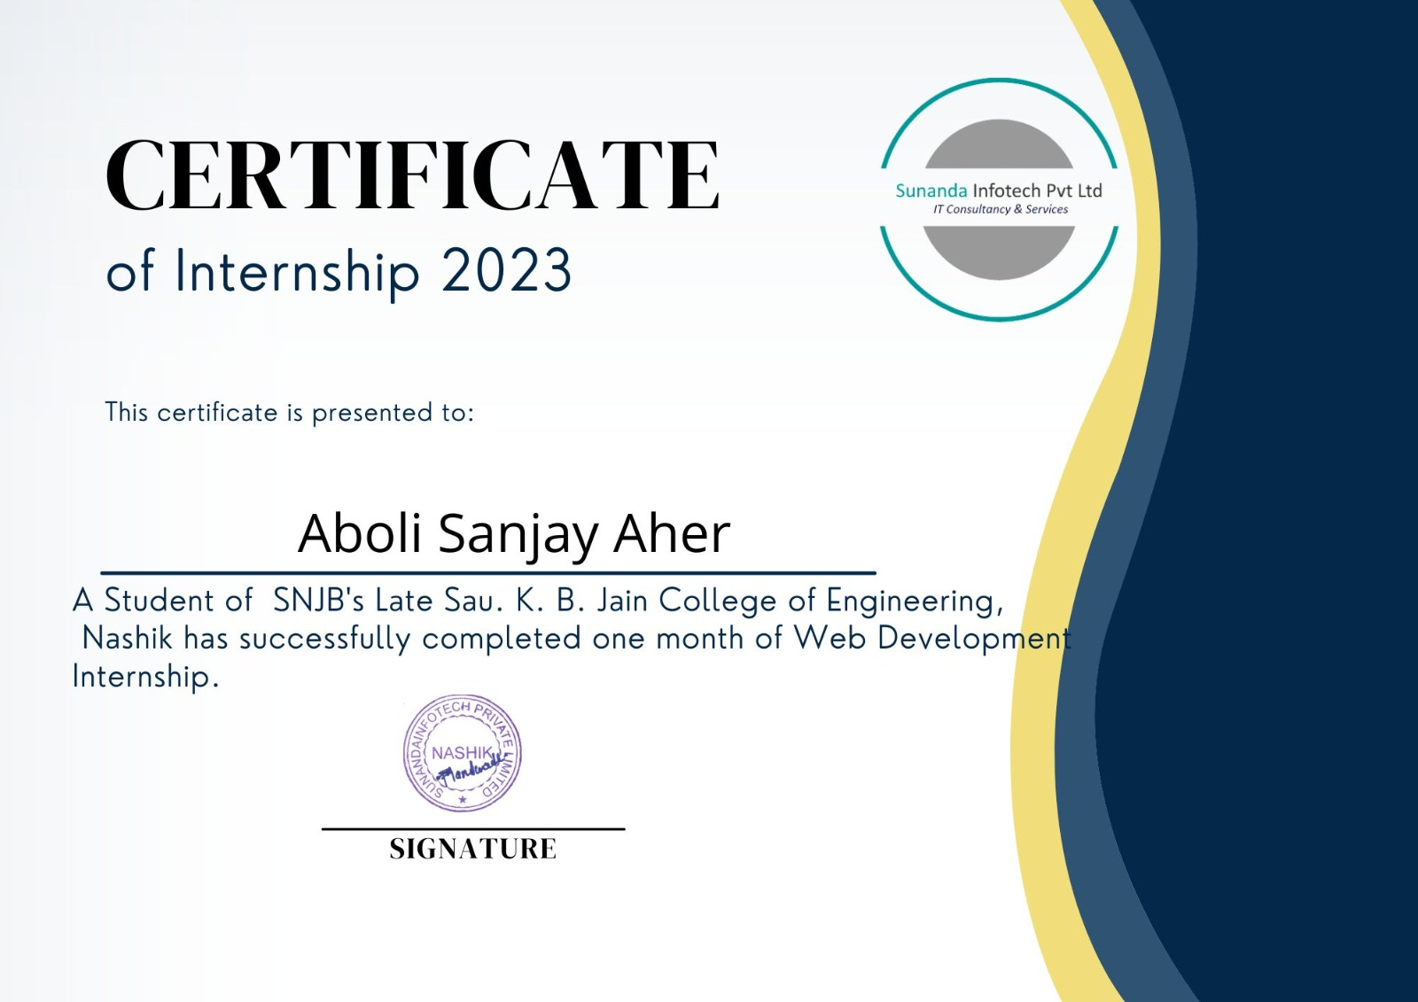

# INTERNSHIP PLACE DETAILS

### Company Profile :

### Name of company: Sunanda Infotech Pvt.Ltd.

### Location/ address/ pin code:  Office No-105, Tirumala Heights, Panchavati, Nashik, Maharashtra 422002, Nashik, Maharashtra 422001.

### Establishment: 2017.

### Email:  sunandainfotech.firm@gmail.com

### Web Address: https: //www.sunandainfotech.com/

### Type of product: Manufacturing industry

### Type of control: Private

### Type of company: Small scale

### They transform Ideas Into Successful Implementations With over 7 years of experience in outsourcing software development. They have 1200 project are completed and 3781customer services.Sunandainfotech.Pvt.Ltd is a leading Information Technology (IT) Service provider in Nashik and Mumbai, who delivers the complete solution for the entire software necessities with the assured quality. We proved our competence in IT consulting, Technology services, R&D and Technology service, IEEE project development, corporate training, Academic Project enhancement, Business Process Outsourcing, Web Designing, Content writing, Research Article submission, Blogger services, and Management solution. To leverage there expertise and skills to get relief

### from their short and long-term software development needs.

Sunandainfotech Private Limited is an unlisted private company incorporated on 18 April, 2017. It is classified as a private limited company and is located in Nashik, Maharashtra. It's authorized share capital is INR 1.00 lac and the total paid-up capital is INR 1.00 lac.

**Description**: This company provides web application designing, mobile application development & pathology lab application services.

**Product and Services** : Web application designing, Mobile application development and pathology lab application.

**Category**: Service Provider

The current status of Sunandainfotech Private Limited is - Active.

The last reported AGM (Annual General Meeting) of Sunandainfotech Private Limited, per our records, was held on 29 November, 2021.

Sunandainfotech Private Limited has two directors - [Vishal Sudam Mandwade](https://www.tofler.in/vishal-sudam-mandwade/director/07781639) and [Siddharth Sudam Mandwade](https://www.tofler.in/siddharth-sudam-mandwade/director/07781824).

The Corporate Identification Number (CIN) of Sunandainfotech Private Limited is U72900MH2017PTC293957. The registered office of Sunandainfotech Private Limited is at R/H 13, SAI SHRIJI R/H, PL-234, SN 491/A, NEAR SHRIRAM NAGAR,, Nashik, Nashik, Maharashtra.

### Vision & Values

The most admired Information Technology Solution Providers globally with leadership focus in delivery of products, solutions and services which are globally competitive.

### The New Generation Of Sunanda Infotech:

* + Delivery of Product and Services which are globally competitive.
  + Continuous improvement of our products, processes and people.
  + Continuous satisfaction of our customers , shareholders and employees.

### Mission

Sunanda Infotech Pvt.Ltd. Information Technology will provide products and services that not only meet but exceed the expectation of our customers through planned and continuous improvement of our Services,Products, Processes and People.

The Mission of the Human Resources Department, is to Recruit, Develop and Retain the High-Caliber Diverse workforce

* + Employee centric organization
  + Well defined the processes
  + Long term engagement with multiple project opportunities
  + Diversity in verticals/domain focus – Finance, Telecom, Technology, Shipping, Airlines, Medical….…
  + Well carved learning curve with performance management system
  + Rewards & Recognition
  + Cross training/learning opportunities & redeployment opportunities

### Building Commitment:

* + Focus – Employees are given equal opportunities
  + Involvement – Marching together towards common goal
  + Development – Encourage opportunities for learning and growth
  + Gratitude – Recognize performance (formal or informal)
  + Accountability – Employees are given freedom to work and outshine.

# STUDENT’S DECLARATION

I, the undersigned, hereby declare that, the project entitled, **“HR Management System Project”**is executed as per the course requirement of four year full time B. E. program of Savitribai Phule Pune University. This report has not been submitted by me or any other person to any other University or Institution for a degree or diploma course. This is my own and original work.

**Place: Nashik.**

**Date:**…………………..

**Aher Aboli Sanjay**

**PRN-72149815K**

# INDEX

|  |  |  |
| --- | --- | --- |
| **Chapter No.** | **Title of Contents** | **Page No** |
|  | Acknowledgement | i |
|  | College Certificate | ii |
|  | Internship Completion Certificate | iii |
|  | Internship Place Details | iv |
|  | Student’s Declaration | v |
| 1 | Introduction |  |
| 2 | Abstract |  |
| 3 | Objectives of the Study |  |
| 4 | Training work undertaken |  |
| 5 | Result and Discussion |  |
| 6 | Motivation |  |
| 7 | Internship Outcome |  |
| 8 | Future Scopes |  |
| 9 | Conclusion |  |

**Chapter 1: Introduction**

As a full-time student SNJB’s KBJ COE,Chandwad, I was provided an opportunity to

undertake an internship at Sunanda Infotech Pvt.Ltd. The degree towards I

am currently studying is a Bachelor of Engineering in Artificial Intelligence and Data

Science. The course at UI was quite challenging for me for a few reasons: Firstly, the

programming languages and development tools I was using were new for me, hence I had

to quickly integrate not only with my new living environment but also academically. This was

very beneficial for me as at the end I could compare what I’ve learnt with what I already

know and find a connection between the two.

This report is a description of my 4 weeks internship carried out as a compulsory component

of the course at UI. In the following chapter details of tools and technology used and an

overview is given. Afterwards, I explain my role and tasks as a trainee and give specific

technical details about my main tasks. Finally, a conclusion is drawn from the experience.

# Chapter 2: ABSTRACT

### Project Objective and Brief:

TCS ION Digital Learning platform is a content marketplace for learning products and offerings. The project requires preparing webpages (microsites) for a product to make it sale ready.

### Project Guidelines:

**Create Two Web Pages**

### Part-1

1. Take the sample Microsite Briefing Template (MBT) and login into a dummy environment available for the learning platform as provided by the Industry Mentor.
2. Click on the template creation tab and fill in the required details.
3. Create the product code using standard nomenclature (<Product Name><Title><Date><Month <Year>).
4. Fill in the details from the MBT into the respective sections.

### Part-2

1. Go to the webtop application and login using dual authentication.
2. Search for the project code created in Part 1 step 3.
3. Approve the project code.
4. Click on the link provided in the MBT on the dummy environment.
5. Test the webpage for device compatibility.

### Project Outcome:

1. Creation of web pages based on a set of inputs.
2. To ensure device compatibility for the web pages.

### Hands-on Details:

The hands on environments or software required to implement the project are:

1. MS Office
2. HTML5/CSS3
3. Notepad++

### Primary Objectives:

1. Earning a position with a dynamic and progressive web development organization in TCS, and applying my advanced education in web development platforms to the creation of new web services and renovation of existing websites forTCS.
2. Self-motivated team player ready to excel is an intern with TCS.
3. Requesting an internship with a well-respected software developer to study the behaviors of professional coders and contribute to the development of premium business software.
4. Independent software developer applying to become a coding intern with TCS to learn to apply my significant coding abilities and strong work ethic in a professional setting.

### Secondary Objectives:

1. Perform literature survey and identify opportunities and challenges
2. Execute proofs of concept
3. Contribute to development of tools and products
4. Learn about emerging trends and technologies in industrial research
5. Define the challenges involved in applied research
6. Articulate research problems and systematically design solutions

# Chapter 3: Motivation / Scope of Internship work

## Motivation Behind Joining the Internship:

My Motivation to do internship in Tata Consultancy Services was as follows:

1. TCS is a global IT Service Provide
2. Tata Consultancy Services (TCS), has become the second-most valuable brand in the IT services sector globally, according to Brand Finance, the world's leading brand valuation firm. India's largest IT company TCS ranked at No. 3 in 2021, after IBM. The Mumbai-based IT company is part of Tata Group.

## Company Profile and Technology:



Tata Consultancy Services (TCS) is an Indian multinational information technology (IT) services and consulting company headquartered in Mumbai.It is a part of the Tata Group and operates in 149 locations across 46 countries.

TCS is the second largest Indian company by market capitalisation and is among the most valuable IT services brands worldwide.In 2015, TCS was ranked 64th overall in the *Forbes* World's Most Innovative Companies ranking, making it both the highest-ranked IT services company and the top Indian company.As of 2018, it is ranked eleventh on the Fortune India 500 list. In April 2018, TCS became the first Indian IT company to reach $100 billion in market capitalisation and second Indian company ever (after Reliance Industries achieved it in 2007) after its market capitalisation stood at ₹6.793 trillion (equivalent to ₹7.7 trillion or US$100 billion in 2020) on the Bombay Stock Exchange.

In 2016–2017, parent company Tata Sons owned 72.05% of TCS[]](https://en.wikipedia.org/wiki/Tata_Consultancy_Services#cite_note-19) and more than 70% of Tata Sons' dividends were generated by TCS. In March 2018, Tata Sons sold stocks of TCS worth $1.25 billion in a bulk deal. As of 15 September 2021, TCS has recorded a market capitalization of US$200 billion, making it the first Indian IT firm to do so.

### History:

Tata Consultancy Services Limited, initially started as "Tata Computer Systems" was founded in 1968 by a division of Tata Sons Limited. Its early contracts included punched card services to sister company TISCO (now Tata Steel), working on an Inter-Branch Reconciliation System for the Central Bank of India, and providing bureau services to Unit Trust of India.

In 1975, TCS delivered an electronic depository and trading system called SECOM for Swiss company SIS SegaInterSettle; it also developed System X for the Canadian Depository System and automated the Johannesburg Stock Exchange. TCS was associated with a Swiss partner, TKS Teknosoft, which it later acquired.

In 1980, TCS established India's first dedicated software research and development center, the Tata Research Development and Design Center (TRDDC) in Pune. In 1981, it established India's first client-dedicated offshore development center, set up for clients Tandem. TCS later (1993) partnered with Canada-based software factory Integrity Software Corp, which TCS later acquired.

In anticipation of the Y2K bug and the launch of a unified European currency (Euro), Tata Consultancy Services created the factory model for Y2K conversion and developed software tools which automated the conversion process and enabled third-party developer and client implementation. Towards the end of 1999, TCS decided to offer Decision Support System (DSS) in the domestic market under its Corporate Vice President and Transformation Head Subbu Iyer.

On 25 August 2004, TCS became a publicly listed company.

In 2005, TCS became the first India based IT services company to enter the bioinformatics market.In 2006, it designed an ERP system for the Indian Railway Catering and Tourism Corporation. By 2008, its e-business activities were generating over US$500 million in annual revenues.

TCS entered the small and medium enterprises market for the first time in 2011, with cloud-based offerings. On the last trading day of 2011, it overtook RIL to achieve the highest market capitalisation of any India-based company. In the 2011–12 fiscal year, TCS achieved annual revenues of over US$10 billion for the first time.

In May 2013, TCS was awarded a six-year contract worth over ₹11 billion (US$140 million) to provide services to the Indian Department of Posts.In 2013, the firm moved from the 13th position to 10th position in the *League of top 10 global IT services companies* and in July 2014, it became the first Indian company with over ₹5 trillion (equivalent to ₹6.8 trillion or US$89 billion in 2020) market capitalisation.

In Jan 2015, TCS ended RIL's 23-year run as India's most profitable firm.

In Jan 2017, the company announced a partnership with Aurus, Inc., a payments technology company, to deliver payment solutions for retailers using TCS OmniStore, a first of its kind unified store commerce platform.In the same year, TCS China was associated as a joint venture with the Chinese government.

TCS announced its FY19 Q3 results posting 24 per cent year-on-year (YoY) rise in profit at ₹81.05 billion (equivalent to ₹86 billion or US$1.1 billion in 2020). The stock plunged 2.5 per global ippo/illa/ega oh ippo/illa/ega zero cent intra-day as brokerages cut price targets.

TCS received the 2019 American Business Awards from Four Stevies.

On 8 October 2020, TCS surpassed Accenture in market capitalisation to become the world's most-valuable IT company with a market cap of $144.73 billion. On 25 January 2021, TCS again surpassed Accenture briefly, in market capitalization to become the world's most-valuable IT company with a market cap of $170 billion. The same day, TCS became India's most valuable company, surpassing Reliance Industries with a market cap of ₹12.55 trillion (US$160 billion). In 2021 Tata is also one of the largest job providers in India hiring 43,000 individuals in H1 FY22.

### Industries:

1. Banking and Financial Services.
2. Consumer Goods and Distribution
3. Education
4. HiTech
5. Insurance
6. Manufacturing
7. Retail
8. Capital Markets
9. Communications Media and Technology
10. Energy Resources and Utility
11. Information Services
12. Life Sciences and Healthcare
13. Public Services
14. Travel, Transportation and Hospitality

### Services:

1. Analytics and Insights
2. Blockchain
3. Cognitive Business Operations
4. Cyber Security
5. Enterprise Applications
6. Quality Engineering
7. Automation and AI
8. Cloud
9. Consulting
10. IOT and Digital Engineering
11. TCS Interactive
12. Sustainability Services

### Products:

1. TCS BaNCS™
2. TCS Connected Intelligence Platform™
3. ignio™
4. TCS iON™
5. TCS MasterCraft™
6. TCS Optumera™
7. TAP™
8. CHROMA™
9. TCS Customer Intelligence & Insights™
10. TCS Intelligent Urban Exchange™
11. Jile™
12. TCS OmniStore™
13. Quartz™ - The Smart Ledgers

### Platforms:

1. TCS ADD™
2. TCS BFSI Platforms
3. ERP on Cloud
4. TCS HOBS™

### Scope of Technology in Market:

There are numerous web developer jobs available in the market for those with the requisite skills. We discussed the trending technologies earlier – it goes without saying that it is essential for developers to master those technologies: IoT, AI, VR, AR, in addition to the latest programming languages, platforms, tools, and so on. If you aspire to be a web development professional, make sure you learn all these skills.

Which industries are likely to provide you with a career in web development? Almost every industry uses web development for their business:

* + Manufacturing
  + Retail
  + Entertainment
  + Education
  + Banking and Insurance
  + Advertisement Agencies
  + Supply Chain
  + Hospitality
  + Travel
  + Professionals

Even software development, mobile app development, and digital marketing companies have their own websites obviously.

You can opt to do either a long-term or short-term web development course, and you can find work as any of the following:

* + Web App Developer
  + UI Designer
  + Front-end or Backend Developer
  + UX Architect
  + UX Designer
  + Web Marketing Analyst

You can either be part of a software company or freelance. There is immense scope for either. A freelancer is not likely to have a fixed income, but more freedom; you can pick and choose your projects. A fresh recruit is likely to earn Rs. 1,25,000 per annum, whereas an experienced developer can earn up to 6 or 7 times more.

### Is Web Development a Good Career?

Web development can be an excellent, lucrative career, if you are passionate about developing websites, web apps, or doing UI/UX work. However, you need to frequently upgrade your skills as it is a continuously evolving field.

Webandcrafts is one of the leading website development companies in Kerala, India. Our services include eCommerce development, website designing, mobile application development, digital marketing, etc. We are

committed to providing the best services to our customers meeting industrial and business standards. If you have any queries on eCommerce development, contact us right away.

### Scope of Project in Market:

1. Communicate effectively with your visitors by offering valuable content, and responding in time to their queries, grievances, and suggestions
2. Expand your reach, attract more traffic to your website, and improve your connect with your target audience
3. Show potential customers that you are serious about your business, and build trust and confidence among customers about your brand.
4. Maintain ownership of your brand identity and protect it from being hijacked by third-party websites and ads
5. Send across the right message to your target audience and existing customers with relevant, useful and current information
6. Create a content hub
7. Have optimized websites which succeeds in attracting organic, search engine traffic, and improve chances of converting visitors
8. Analyze website statistics like conversion rates, visitor engagement, and more, to help you craft or alter your marketing strategy

# Chapter 4: Methodological details / Live project details

### HTML:

The **HyperText Markup Language** or **HTML** is the standard markup language for documents designed to be displayed in a web browser. It can be assisted by technologies such as Cascading Style Sheets (CSS) and scripting languages such as JavaScript.

Web browsers receive HTML documents from a web server or from local storage and render the documents into multimedia web pages. HTML describes the structure of a web page semantically and originally included cues for the appearance of the document.

HTML elements are the building blocks of HTML pages. With HTML constructs, images and other objects such as interactive forms may be embedded into the rendered page. HTML provides a means to create structured documents by denoting structural semantics for text such as headings, paragraphs, lists, links, quotes and other items. HTML elements are delineated by *tags*, written using angle brackets. Tags such as <**img** /> and <**input** /> directly introduce content into the page. Other tags such as <**p**> surround and provide information about document text and may include other tags as sub-elements. Browsers do not display the HTML tags but use them to interpret the content of the page.

HTML can embed programs written in a scripting language such as JavaScript, which affects the behavior and content of web pages. Inclusion of CSS defines the look and layout of content. The World Wide Web Consortium (W3C), former maintainer of the HTML and current maintainer of the CSS standards, has encouraged the use of CSS over explicit presentational HTML since 1997.A form of HTML, known as HTML5, is used to display video and audio, primarily using the <**canvas**> element, in collaboration with javascript.

**Hypertext markup language (HTML)** is a Hypertext markup language, the standard markup language for documents designed to displayed and viewed on the online during a browser also helps to create the structure of the web page. because it is a markup language, it consists of many tags. There are tags to display text, tables, ordered lists and unordered lists, etc. There are two main sections on the HTML page: head and body section. The data that describes the page also termed as metadata is inside the head section while the body section includes all the tags that are necessary to represent the visible content of the web page HTML is a platform-independent language so that can be made in use in any platform like Windows, Linux, Macintosh, etc.

There are various HTML versions. The newest version is HTML 5. it’s more advanced features like Geo-location, native audio, and video support, Canvas, web socket, etc. Usually, HTML is a simple language to find out and use. A programmer can create an HTML file employing a simple text editor and execute it employing a browser.

### Advantages of HTML:

1. HTML is widely used.
2. Every browser supports HTML Language.
3. Easy to learn and use.
4. HTML is lightweight and fast to load.
5. Do not get to purchase any extra software because it’s by default in every window.
6. Easy to use
7. Loose syntax (although, being too flexible won’t suit standards).
8. HTML is easy enough to write
9. HTML is that it is easy to code even for novice programmers.
10. HTML also allows the utilization of templates, which makes designing a webpage easy.
11. Very useful for beginners in the web designing field.
12. HTML can be supported to each and every browser, if not supported to all the browsers.
13. HTML is built on almost every website, if not all websites.
14. HTML is increasingly used for data storage like XML syntax.
15. Free – You need not buy any software.
16. HTML is present in every window by default so you do not need to buy the software which costs too much.
17. HTML has many tags and attributes which can short your line of code.

### Disadvantages of HTML:

1. It cannot produce dynamic output alone, since it’s a static language.
2. Making the structure of HTML documents becomes tough to understand.
3. Errors can be costly.
4. It is as time consuming as the time it consumes to maintain the color scheme of a page and to make lists, tables and forms.
5. It can create only static and plain pages so if we’d like dynamic pages then HTML isn’t useful.
6. Required to write a lot of code for just creating a simple webpage.
7. We have to check up the deprecated tags and confirm not to use them to appear because another language that works with HTML has replaced the first work of the tag, and hence the opposite language needs to be understood and learned.
8. Security features offered by HTML are limited.
9. If we need to write down long code for creating a webpage then it produces some complexity.
10. HTML can create only static and plain pages so if we’d like dynamic pages then HTML isn’t useful.
11. I need to write down tons of code for creating an easy webpage.
12. Security features are not good at HTML.
13. If we’d like to write down long code for creating a webpage then it produces some complexity.

### CSS:

**Cascading Style Sheets** (**CSS**) is a style sheet language used for describing the presentation of a document written in a markup language such as HTML.CSS is a cornerstone technology of the World Wide Web, alongside HTML and JavaScript.

CSS is designed to enable the separation of presentation and content, including layout, colors, and fonts.This separation can improve content accessibility; provide more flexibility and control in the specification of

presentation characteristics; enable multiple web pages to share formatting by specifying the relevant CSS in a separate .css file, which reduces complexity and repetition in the structural content; and enable the .css file to be cached to improve the page load speed between the pages that share the file and its formatting.

Separation of formatting and content also makes it possible to present the same markup page in different styles for different rendering methods, such as on-screen, in print, by voice (via speech-based browser or screen reader), and on Braille-based tactile devices. CSS also has rules for alternate formatting if the content is accessed on a mobile device.

The name *cascading* comes from the specified priority scheme to determine which style rule applies if more than one rule matches a particular element. This cascading priority scheme is predictable.

The CSS specifications are maintained by the World Wide Web Consortium (W3C). Internet media type (MIME type) text/css is registered for use with CSS by RFC 2318 (March 1998). The W3C operates a free CSS validation service for CSS documents.

In addition to HTML, other markup languages support the use of CSS including XHTML, plain XML, SVG, and XUL.

CSS is defined as a method sheet language that provides web designers control over how an internet site communicates with web browsers including the formatting and display of their HTML documents.

CSS or cascading sheet may be a text-based coding language that specifies the website formats and the way a site communicates with web browsers. The language allows web developers to regulate various style elements and functionalities, like layout, color, fonts, and therefore the formatting and display of HTML documents.

The main goal (as a method sheet language) was to separate document content from document presentation, which incorporates style elements, like color, layout, and fonts. CSS handles the design and feels a part of an internet page. Using CSS, you will control the color of the text, the design of fonts, the spacing between paragraphs, how columns are sized and laid out, etc.

CSS instructs the display of the HTML on how the web site will display at the user’s end. Let us have a glance on the benefits and drawbacks of CSS.

### Advantages of CSS:

1. CSS plays an important role, by using CSS you simply got to specify a repeated style for an element once & use it multiple times because CSS will automatically apply the required styles.
2. The main advantage of CSS is that style is applied consistently across a variety of sites. One instruction can control several areas which is advantageous.
3. Web designers need to use a few lines of programming for every page improving site speed.
4. Cascading not only simplifies website development, but also simplifies maintenance as a change of one line of code affects the whole web site and maintenance time.
5. It is less complex therefore the effort is significantly reduced.
6. It helps to form spontaneous and consistent changes.
7. CSS changes are device friendly. With people employing a variety of smart devices to access websites over the web, there’s a requirement for responsive web design.
8. It has the power for re-positioning. It helps us to determine the changes within the position of web elements who are there on the page.
9. These bandwidth savings are substantial figures of insignificant tags that are indistinct from a mess of pages.
10. Easy for the user to customize the online page
11. It reduces the file transfer size.

### Disadvantages of CSS:

1. CSS, CSS 1 up to CSS3, result in creating confusion among web browsers. With CSS, what works with one browser might not always work with another. The web developers need to test for compatibility, running the program across multiple browsers.
2. There exists a scarcity of security.
3. After making the changes we need to confirm the compatibility if they appear. The similar change affects all the browsers.
4. The programming language world is complicated for non-developers and beginners. Different levels of CSS

i.e. CSS, CSS 2, CSS 3 are often quite confusing.

1. Browser compatibility (some styles sheets are supported and some are not). CSS works differently on different browsers. IE and Opera support CSS with different logic.
2. There might be cross-browser issues while using CSS.
3. There are multiple levels which creates confusion for non-developers and beginners.

### Bootstraps:

Bootstrap is a free and open-source CSS framework directed at responsive, mobile-first front-end web development. It contains HTML, CSS and (optionally) JavaScript-based design templates for typography, forms, buttons, navigation, and other interface components.

As of April 2022, Bootstrap is the eleventh most starred project on GitHub, with over 156,000 stars, behind freeCodeCamp, Vue.js framework, React library, TensorFlow and others.

Bootstrap is an HTML, CSS & JS Library that focuses on simplifying the development of informative web pages (as opposed to web apps). The primary purpose of adding it to a web project is to apply Bootstrap's choices of color, size, font and layout to that project. As such, the primary factor is whether the developers in charge find those choices to their liking. Once added to a project, Bootstrap provides basic style definitions for all HTML elements. The result is a uniform appearance for prose, tables and form elements across web browsers. In addition, developers can take advantage of CSS classes defined in Bootstrap to further customize the appearance of their

contents. For example, Bootstrap has provisioned for light- and dark-colored tables, page headings, more prominent pull quotes, and text with a highlight.

Bootstrap also comes with several JavaScript components in the form of jQuery plugins. They provide additional user interface elements such as dialog boxes, tooltips, and carousels. Each Bootstrap component consists of an HTML structure, CSS declarations, and in some cases accompanying JavaScript code. They also extend the functionality of some existing interface elements, including for example an auto-complete function for input fields.

### Market Share of HTML:

HTML is used by **94.5%** of all the websites. HTML5 is used by 90.6% of all the websites.

### Different languages and databases in your project:

1. HTML
2. CSS
3. Bootstraps
4. AngularJS

### Code:

<!DOCTYPE html>

<html>

<head>

<title>Web page</title>

<meta name="viewport" content="width=device-width, initial-scale=1.0">

<!-- CSS only -->

<link href="[https://cdn.jsdelivr.net/npm/bootstrap@5.1.3/dist/css/bootstrap.min.css](https://cdn.jsdelivr.net/npm/bootstrap%405.1.3/dist/css/bootstrap.min.css)" rel="stylesheet" integrity="sha384-1BmE4kWBq78iYhFldvKuhfTAU6auU8tT94WrHftjDbrCEXSU1oBoqyl2QvZ6jIW3" crossorigin="anonymous">

</head>

<style>

/*.container { position: relative; text-align: center; color: white; float: left;

}*/

/*.bottom-right { position: absolute; bottom: 8px; right: 16px; margin-bottom:

}*/

h1{

}

color: yellow;

</style>

<style>

.square { height: 20px; width: 20px;

background-color:green;

}

.square1 { height: 20px;

width: 20px;

background-color:yellow;

}

.square2 { height: 20px; width: 20px;

background-color:orange;

}

.square3 { height: 20px; width: 20px;

background-color:red;

}

</style>

</head>

<body >

<div class="container-fluid" style="background-image: url(8.png);background-repeat: no-repeat;width: 1349px;height: 387px; background-size: cover;">

</div>

<center><h1 style="color: #ffA701;text-align: center;margin-top: 59px; font-size: 55px">Note for Teachers And Administrators</h1>

<p class="text-start" style="margin-left: 205px; margin-bottom: -10px;font-size: 16px;">The TCS iON Sharpener Learning Analysis Report is intended for techers and schools administrators. This report provides an aggregate<br> view of the performance of students in subject and can be used by school teachers and administratorsfor effective planning and <br>monitoring of student learning. Teachers and school administrators can use this report to understand the performance of students at<br> various levels of granularity, from overall subject level all the question level</p><br></center>

<p style="margin-left: 207px; font-size: 17px;">The indicators for each performance level,can be interpreted as follws:</p>

<img src="Pencil.png" style="width: 936px;margin-left: 198px;margin-top: 15px;">

Dashboard</h1>

<div class="container" style=" margin-right: 221px;">

<h1 style="color: #ffA701; margin-top: 127px;margin-left: 196px">Subject

<h4 style="margin-left: 197px;">Total Numbers of Students: <strong>150</strong></h4>

1025px; margin-left: 200px;">

#73b504">Completion Rate</th>

<table class="table table-bordered primary" style="width:

<tr>

<th class="bg-primary" colspan="">Topic</th>

<th colspan="2" style="background-color:

class="bg-warning">Performance Levels</th> class="bg-primary">Performance Gains</th>

</tr>

<tr>

<th colspan="2"

<th colspan="2"

<td class="bg-primary"></td>

<td style="background-color: #73b504">Attempt

1</td><td style="background-color: #73b504">Attempt 2</td> class="bg-warning">Attempt 2</td>

</tr>

<tr>

<td class="bg-warning">Attempt 1</td><td

<td class="bg-primary"> </td>

<td class="table-info">1.Exponents and Decimal

System</td>

src="Level_004.png"></td> src="Positive.png"></td>

using the Laws of Exponents </td> class="table-success">100%</td>

</tr>

<tr>

<td>100%</td><td>100%</td>

<td><img src="Level_002.png"></td><td><img

<td class="table-info"><img

<td>2.The laws of Exponents & Examples <br>of

<td class="table-success">100%</td><td

<td class="table-warning"><img

src="Level_002.png"></td><td class="table-warning"><img src="Level_003.png"></td>

<td><img src="Positive.png"></td>

</tr>

Numbers in the Standard form </td>

src="Level_003.png"></td> src="Neutral.png"></td>

form </td>

class="table-success">10%</td>

</tr>

<tr>

<tr>

<td class="table-info">3.Expression Large

<td>100%</td><td>80%</td>

<td><img src="Level_003.png"></td><td><img

<td class="table-info"><img

<td>4.Expression Large Numbers in the Standard

<td class="table-success">80%</td><td

<td class="table-warning"><img src="Level_003.png"></td><td class="table-warning"><img src="Level_001.png"></td>

<td><img src="sad.png"></td>

</tr>

<tr>

</tr>

<td class="table-info">5.Topic Name </td>

<td>40%</td><td>-</td>

<td><img src="Level_001.png"></td><td>-</td>

<td class="table-info">-</td>

class="table-success"></td> class="table-warning"></td>

<tr>

</tr>

<td>6.Topic Name </td>

<td class="table-success"></td><td

<td class="table-warning"></td><td

<td></td>

<tr>

<td class="table-info">7.Topic Name</td>

<td></td> <td></td>

<td></td>

<td ></td>

<td class="table-info"></td>

</tr>

><strong>8.Average</strong> </td>

<tr>

<td class="bg-primary" style="color: white;"

<td style="background-color:

#73b504">87%</td><td style="background-color: #73b504">73%</td>

<td class="bg-warning"><img src="Level_002.png"></td><td class="bg-warning"><img src="Level_003.png"></td>

<td class="bg-primary"><img

src="Positive.png"></td>

</tr>

</table>

<div class="note" style="margin-left: 196px">

<h4 ><strong>Notes</strong></h4>

<p><strong>. Completion Rate:</strong>Percentage of students who

have completed this attempt for this attempt<br>

<strong>. Performance Level:</strong>Average performance level of students who have attempted this topic<br>

<strong>. Performance Trend:</strong>Understand change in performance level between two attempts<br></p>

</div>

</div>

-110px;">

Dashboard</h1> class="btn-group">

<div class="container" style="margin-left: 138px;" >

<div class="dropdown" style="margin-bottom: 10px; margin-left:

<h1 style="color: #ffA701; margin-top:102px;margin-left: 103px">Topic

<h6 style="margin-left: 112px;"><strong>Select Topic:</strong> <div

<button class=" btn-sm dropdown-toggle" type="button"

data-toggle="dropdown" aria-haspopup="true" aria-expanded="false">Powers and Exponent </button> </h6>

</div>

Rate</h5>

1</th> 2</th>

<div class="row">

<div class="col-md-6">

<table class="table">

<h5>Assessment Completion

<thead>

<th class="bg-primary">Attempt

<th class="bg-primary">Attempt

</thead>

<tbody style="height: 62px;">

class="table-info">100%</td>

1</th> 2</th>

class="bg-primary">Gain</th>

<td

<td class="table-info">80%</td>

</tbody>

</table>

</div>

<div class="col-md-6">

<table class="table">

<h5>Overall Performance</h5>

<thead>

<th class="bg-primary">Attempt

<th class="bg-primary">Attempt

<th

</thead>

<tbody>

<td class="table-info"><img

src="Level_003.png"></td>

src="Level_004.png"></td> src="Positive.png"></td>

</div>

</div>

</div>

<td class="table-info"><img

<td class="table-info"><img

</tbody>

</table>

<h5 style="margin-top: 30px;margin-left: 143px;">Concept and Application Wise

performance:</h5> <div class="container" style=" margin-left: 141px;">

<div class="row">

<table class="table table-bordered primary">

<thead>

<tr>

>Concepts and Applications</th> 1</th>

>Attempt 2</th>

>Gains</th>

Exponents and Decimal System</td>

<th style="color: white; background-color: #25b9be"

<th style="color: white; background-color: #25b9be">Attempt

<th style="color: white; background-color: #25b9be"

<th style="color: white; background-color: #25b9be"

</tr>

</thead>

<tbody>

<tr>

<td>Exponents and Decimal System</td>

<td><img src="Level_002.png"> </td>

<td><img src="Level_004.png"> </td>

<td><img src="Positive.png"> </td>

</tr>

<tr>

<td class="table-secondary">Exponents and Decimal System

<td class="table-secondary"><img src="Level_003.png"></td>

<td class="table-secondary"><img src="Level_004.png"></td>

<td class="table-secondary"><img src="Positive.png"></td>

</tr>

<tr>

<td>Expression Large Numbers in the Standard form</td>

<td><img src="Level_003.png"></td>

<td><img src="Level_002.png"> </td>

<td><img src="sad.png"> </td>

</tr>

</tbody>

</table>

</div>

</div>

>Concept</th>

<h5 style="margin-top: 30px;margin-left: 146px;">Learning Indecator Wise Performance:</h5>

<div class="container" style="margin-left: 140px;">

<div class="row">

<table class="table table-bordered primary">

<thead>

<tr>

<th style="color: white; background-color: #25b9be"

<th style="color: white; background-color:

#25b9be">Attempt 1</th>

>Attempt 2</th>

>Gains</th>

<th style="color: white; background-color: #25b9be"

<th style="color: white; background-color: #25b9be"

</tr>

</thead>

<tbody>

<tr>

given a repeated product</td>

exponent form</td>

<td>Identiifies the correct exponent form(e.g. 34)

<td><img src="Level_002.png"> </td>

<td><img src="Level_004.png"> </td>

<td><img src="Positive.png"> </td>

</tr>

<tr class="table-secondary">

<td>Identifies the correct repeated product given an

<td><img src="Level_003.png"></td>

<td><img src="Level_004.png"></td>

<td><img src="Positive.png"></td>

</tr>

<tr>

number as using power of the tent</td>

exponent form with the same bases</td>

<td>Identifies correct expansion of a multi-digit

<td><img src="Level_003.png"></td>

<td><img src="Level_003.png"> </td>

<td><img src="Neutral.png"> </td>

</tr>

<tr class="table-secondary">

<td>Locates the odd involving the product of two

<td><img src="Level_003.png"></td>

<td><img src="Level_004.png"> </td>

<td><img src="Positive.png"> </td>

</tr>

<tr>

<td>Identifies correct prime factorization</td>

<td><img src="Level_003.png"></td>

<td><img src="Level_002.png"> </td>

<td><img src="sad.png"> </td>

</tr>

</tbody>

</table>

</div>

</div>

<div class="dropdown" style="margin-bottom: 10px;">

<h1 style="color: #ffA701; margin-top: 30px;margin-left: 133px">Question

Dashboard</h1>

<h6 style="margin-left: 138px;"><strong>Select Topic:</strong> <div class="btn-group">

<button class=" btn-sm dropdown-toggle" type="button" data-toggle="dropdown"

aria-haspopup="true" aria-expanded="false">Powers and Exponent </button> </h6>

</div>

<div class="container" style="margin-left:179px;">

<div class="row">

<div class="col-md-1">

<pre> <div class="square"></td> 100%</div></pre>

</div>

<div class="col-md-1">

<pre> <div class="square1"></td> 75%</div></pre>

</div>

<div class="col-md-1">

<pre> <div class="square2"></td> 50%</div></pre>

</div>

<div class="col-md-1">

<pre> <div class="square3"></td> 25%</div></pre>

</div>

<div class="col-md-3" style="margin-top: 20px;">

<pre><p><img src="Hand_Mo.png"></td> Student Records</p></pre>

</div>

<div class="col-md-3" style="margin-top: 20px; margin-left: -118px;">

<pre><p><img src="Tikmark_Mo.png"></td> Correct Response</p></pre>

</div>

</div>

</div>

130px;">

<center><div class="container" style="width:1085px;margin-right:

<div class="row">

<table class="table table-bordered info">

<thead>

<tr>

#25b9be">Question #</th>

#25b9be">% Learners Who Got<br> this Right</th>

>View Question Details</th>

<th style="color: white;background-color:

<th style="color: white;background-color:

<th style="color: white;background-color: #25b9be"

<th colspan="4" class="bg-success"style="color:

white;">Option Analysis<br><h6>(% of Students Who Chose This Incorrect Option.Indicates a right option)</h6></th>

</tr>

</thead>

<tbody>

<td style="background-color: #25b9be"></td>

<td style="background-color: #25b9be"></td>

<td style="background-color: #25b9be"></td>

<td style="background-color: yellow">A</td><td style="background-color: yellow">B</td><td style="background-color: yellow">C</td><td style="background-color: yellow">D</td>

<tr>

<td>1</td>

<td style="background-color: yellow"></td>

<td style="color: blue;">View</td>

<td><img src="Tikmark_Mo.png"></td>

<td></td><td></td><td></td>

src="Tikmark_Mo.png"></td>

</tr>

<tr class="table-info">

<td>2</td>

<td class="bg-success"></td>

<td style="color: pink;"><strong> View</strong></td>

<td class="table-success"></td>

<td class="table-success"><img

<td class="table-success"></td>

<td class="table-success"></td>

</tr>

<tr>

<td>3</td>

<td style="background-color: #FF5800;" ></td>

<td style="color: blue;">View</td>

<td></td><td></td>

<td><img src="Tikmark_Mo.png"></td><td></td>

</tr>

<tr class="table-info">

<td>4</td>

<td class="bg-danger"></td>

<td style="color: blue;">View</td>

<td class="table-success"></td>

src="Tikmark_Mo.png"></td>

<td class="table-success"></td>

<td class="table-success"></td>

<td class="table-success"><img

</div>

</center>

</div>

</tr>

<tr>

<td>5</td>

<td class="bg-success"></td>

<td style="color: blue;">View</td>

<td></td>

<td></td>

<td><img src="Tikmark_Mo.png"></td><td></td>

</tr>

<tr>

</tbody>

</table>

<center>

<div class="card" style="width: 1000px; margin-top: 40px;">

<div class="card-body">

<img src="Wrongmark.png" style="margin-left: 943px;">

<h5>Q1 . Which of the following equivalent to?</h5>

<ul class="group" style="list-style-type: none;">

a.5<sup>4</sup></li>

-25px;">b.4<sup>5</sup></li>

20px;">c. 5 x 4</li>

-20px;">d. 5 + 4</li>

<li class="group">Option: </li>

<li class="group"><img src="Tikmark_Mo.png">

<li class="group" style="margin-left: 20px;margin-bottom:

<img src="Hand_Mo.png" style="margin-right: 80px;">

<li class="group" style="margin-left: 35px;margin-bottom:

<li class="group" style="margin-left: 35px;margin-top:

</ul>

<h6 style="margin-right: 696px;">Learning Insight:</h6>

<p style="margin-left: 50px">The learner interpreted as the 5th

power of 4 instead of 4th power of 5 which suggest that the learner lacked the conceptual knowledge about writing large number in a shorter form using exponents.</p>

</div>

</div>

<h6 style="color: blue; margin-left: 703px;margin-top: 20px;"><img src="Up_Mo.png" > Go to question dashboard</h6>

</body>

</html>

# Chapter 5: DATA ANALYSIS & INTERPRETATION of project

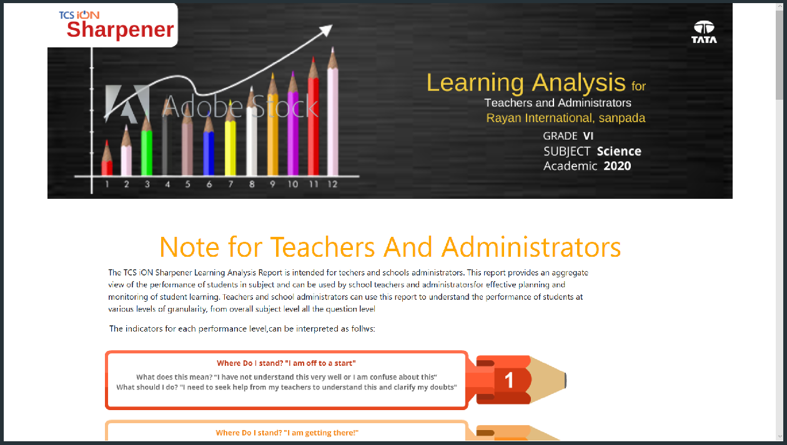**Output:**

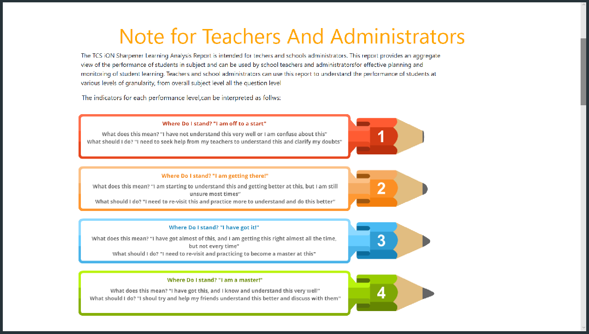

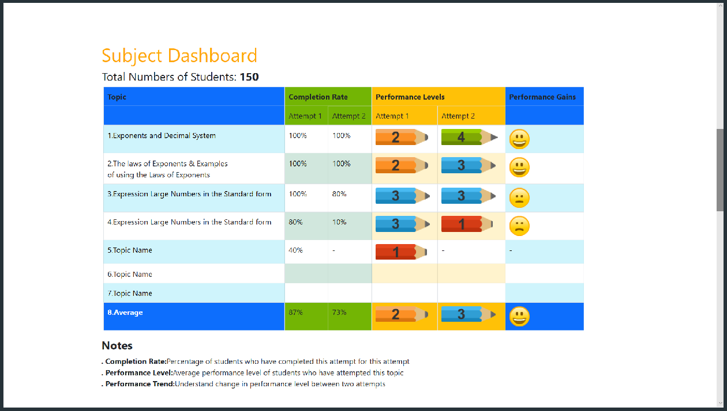

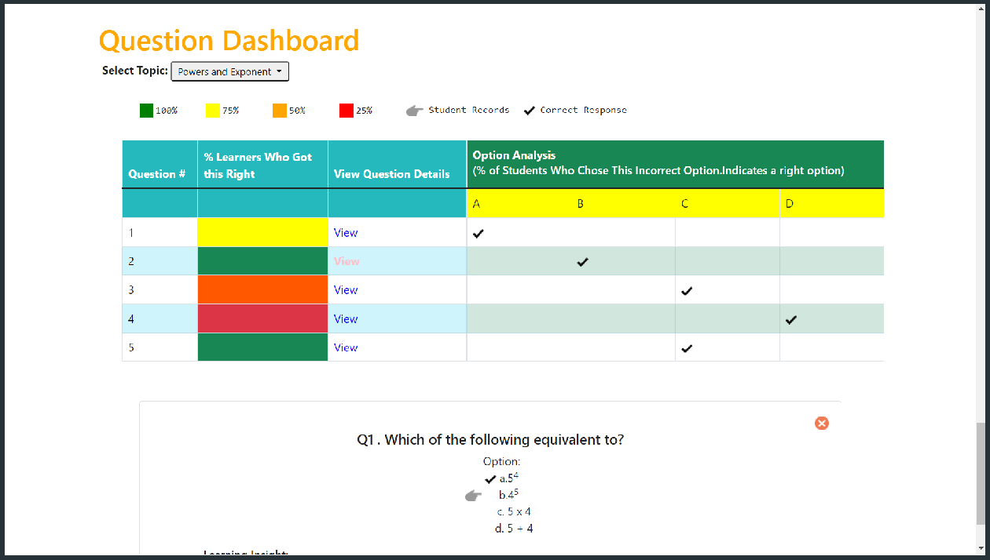

# Chapter 6: Result and Learning from Internship

### Findings:

1. Insert a graphic within a web page.
2. Create a link within a web page.
3. Create a table within a web page.
4. Insert heading levels within a web page.
5. Insert ordered and unordered lists within a web page.
6. Use cascading style sheets.
7. Create a web page.
8. Validate a web page.

### Conclusion:

By using the defined technologies, we have created a website right now. We are developing some more WebPages, and now working on adding further services such as Downloading and online reading. In the end, we want to conclude that practical training is of great importance as it gives the exposure and an opportunity of presenting a seminar before the audience. It develops a sense of responsibility and a feeling of togetherness of working together thereby developing a team spirit for the successful completion of the project. It is an important opportunity which provides the working environment of an organization as to how to deal with the professionals and the customers which plays an important role in building customer satisfaction.

### Learning From Industry:

**How to put my knowledge and skills into practice?**

From conducting comprehensive competitor analysis research, to designing a marketing and communication plan, my knowledge of business and marketing theories was transformed into a series of practical techniques and skills that I can now implement in real-life business scenarios, all thanks to my internship.

### The benefits of networking?

During my internship, I learned how to communicate and build relationships with the people I worked with. I learned how to introduce myself, talk about my interests, knowledge and skills with entrepreneurs and business owners, as well as how to ask questions and gain a better understanding of businesses not only in the co-working space, but also others in the market. This process overall helped me develop my professional network and emphasized the importance of creating these connections. I also connected with most of them via LinkedIn, which is obviously a great networking platform for professionals.

### Understanding workplace culture?

Culture influences communication, and as an international student, I learned that every company or organization has its own culture. It’s essential to observe others and learn how they engage and interact with co-workers, or help them with projects and tasks. I quickly learned that whenever something is unclear for me, or I don’t understand, it’s fine to ask for clarification.

### Enthusiasm is invaluable?

As an intern, I discovered it’s essential to be enthusiastic and open to learning new skills, asking for more work and being curious to learn and ask questions. This attitude will show that you enjoy being part of the team and that you're keen to help. Having curiosity and enthusiasm also means that, as an intern, you get a lot out of what you’re doing, which opens lots of opportunities.

### Keeping a journal is great for personal growth?

During my internship, I had a journal and took notes every day about new things I learned, feedback I was given by my manager, strengths and weaknesses I noticed, and things I wanted to research and learn more about. This helped me understand myself more and identify the areas that I needed to improve in.

### How important is good communication?

Communication is the key to success in a professional environment. I learned that it’s important to communicate with my manager via phone, email or SMS if I have questions or if I don’t know how to work on a task. Asking for help and clarification is better than pretending you’ve understood what you need to do, no matter what. However, I also found that if you can Google something, then do. Avoiding asking questions if you can find answers elsewhere is part of being a good communicator – keep in mind that everyone’s time is valuable. As an intern, good communication will help with productivity, efficiency, engagement and growth.

# Chapter 7: SUGGESTIONS ( if Any)

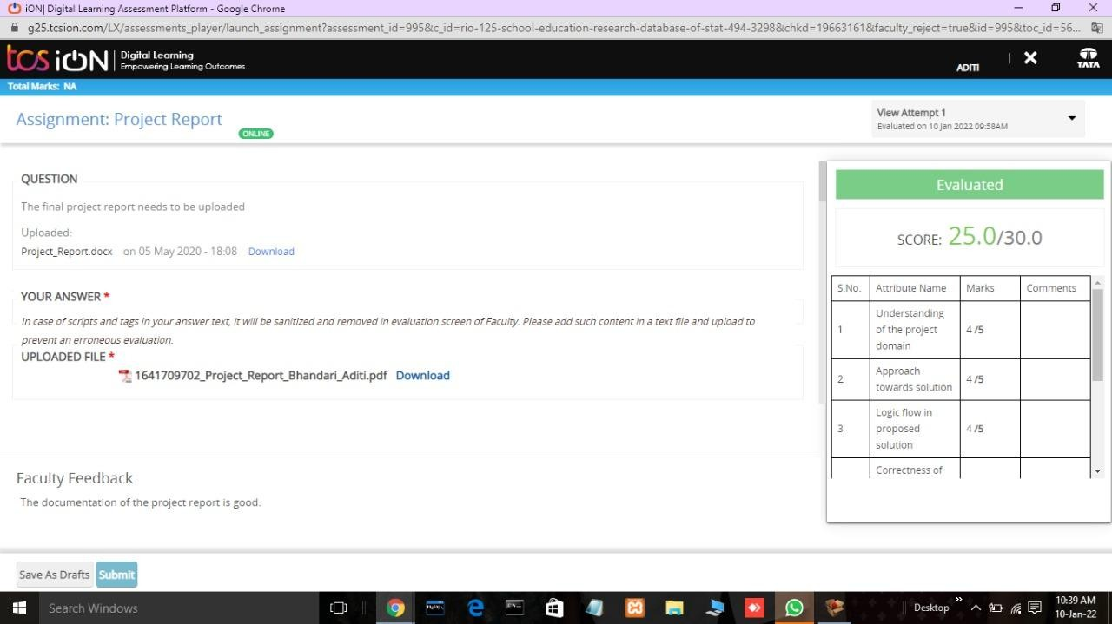

**Chapter 8: ANNEXURE**

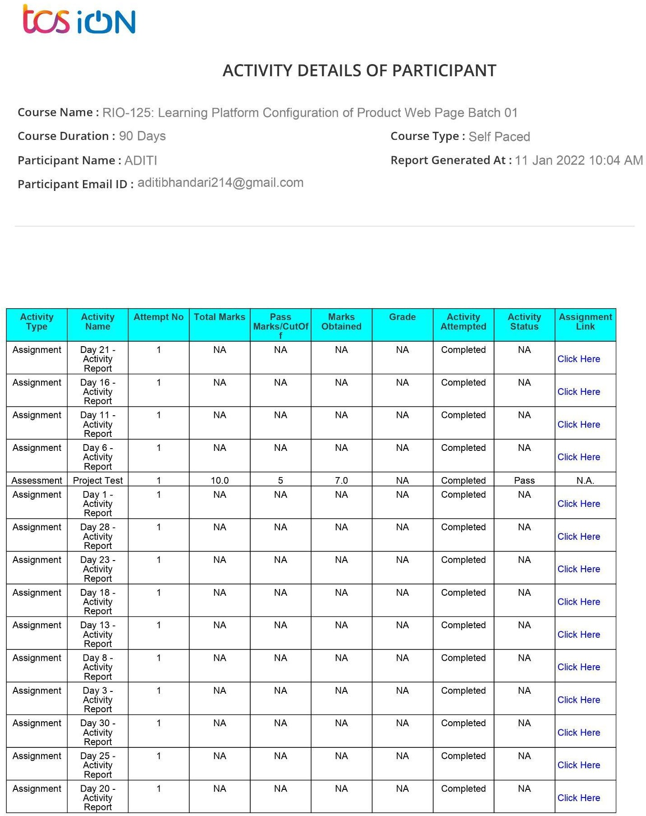

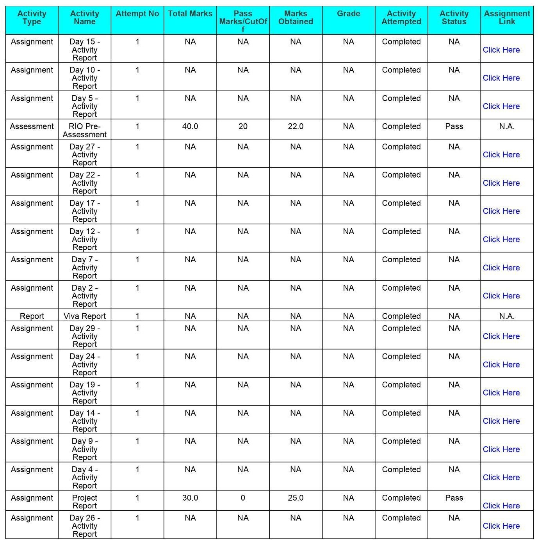

# Chapter 9: BIBLIOGRAPHY

1. [https://helpx.adobe.com/in/support/creative-cloud-dr.html?promoid=NGWGRLZ4](https://helpx.adobe.com/in/support/creative-cloud-dr.html?promoid=NGWGRLZ4&mv=other) [&mv=other](https://helpx.adobe.com/in/support/creative-cloud-dr.html?promoid=NGWGRLZ4&mv=other)
2. <https://helpx.adobe.com/in/photoshop/tutorials.html>
3. <https://helpx.adobe.com/in/illustrator/using/creating-animations.html>
4. [https://helpx.adobe.com/in/support/creative-cloud-dr.html?promoid=NGWGRLZ4](https://helpx.adobe.com/in/support/creative-cloud-dr.html?promoid=NGWGRLZ4&mv=other) [&mv=other](https://helpx.adobe.com/in/support/creative-cloud-dr.html?promoid=NGWGRLZ4&mv=other)
5. <https://helpx.adobe.com/in/photoshop/tutorials.html>
6. <https://helpx.adobe.com/in/illustrator/using/creating-animations.html>
7. <https://www.w3schools.com/html/html5_intro.asp>
8. <https://www.w3schools.com/css/default.asp>
9. <https://www.w3schools.com/js/default.asp> 10.<https://www.w3schools.com/bootstrap4/default.asp> 11.https://jquery.com/